The core philosophy moving forward is to share a story or a prompt with a non-user. For that we will be sharing the stories or prompts via whatsapp, imessage, sms etc. where users will open a weblink
Here are the necessary changes on the frontend side:
We will be talking in terms of Yash(Epochlag user) who will share a story with Vivek(non-user)
We are also changing the designs and share to window flow slightly as per figma.

- Flow1: We don’t know who the replying user is
If Yash shares a story using the above flow without adding anyone i.e. directly opening WhatsApp, then we don’t have any information of who the story is being shared with even if he shared with Vivek on WhatsApp – therefore when Vivek replies he will be required with a quick signup flow. We’ll introduce the onboarding flow on his second session since we anyway call the onboarding status API.

The following will be the flow:
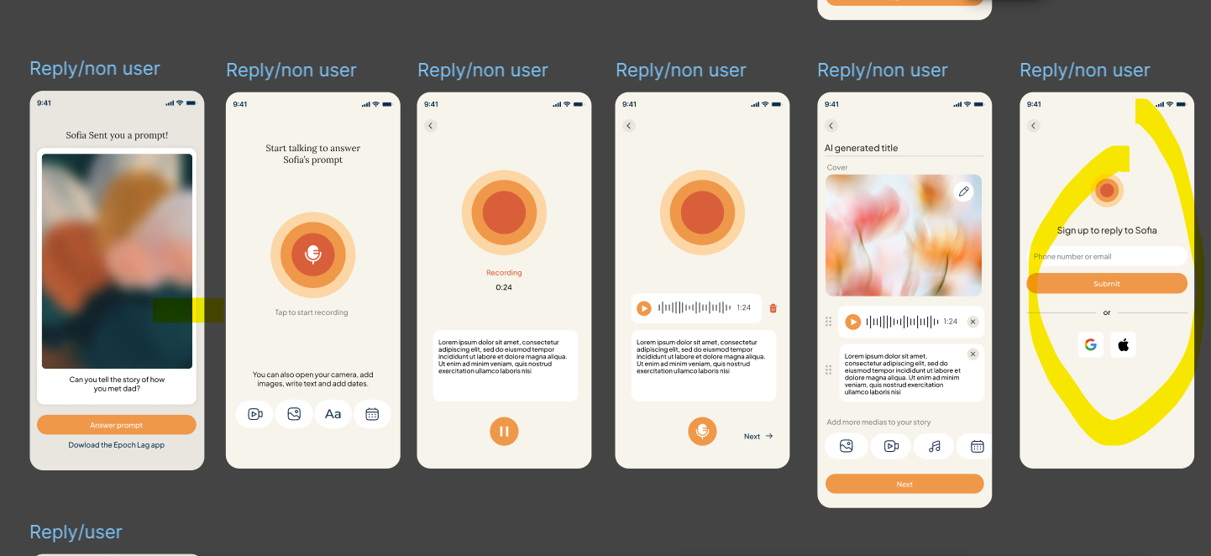

Vivek opens the link, goes through the reply flow, but when he clicks Send, his final step his to verify who he is by entering his phone number(with verify) or social signin. This allows least friction for a reply flow.

- Flow 2 : we know the replying user is Vivek
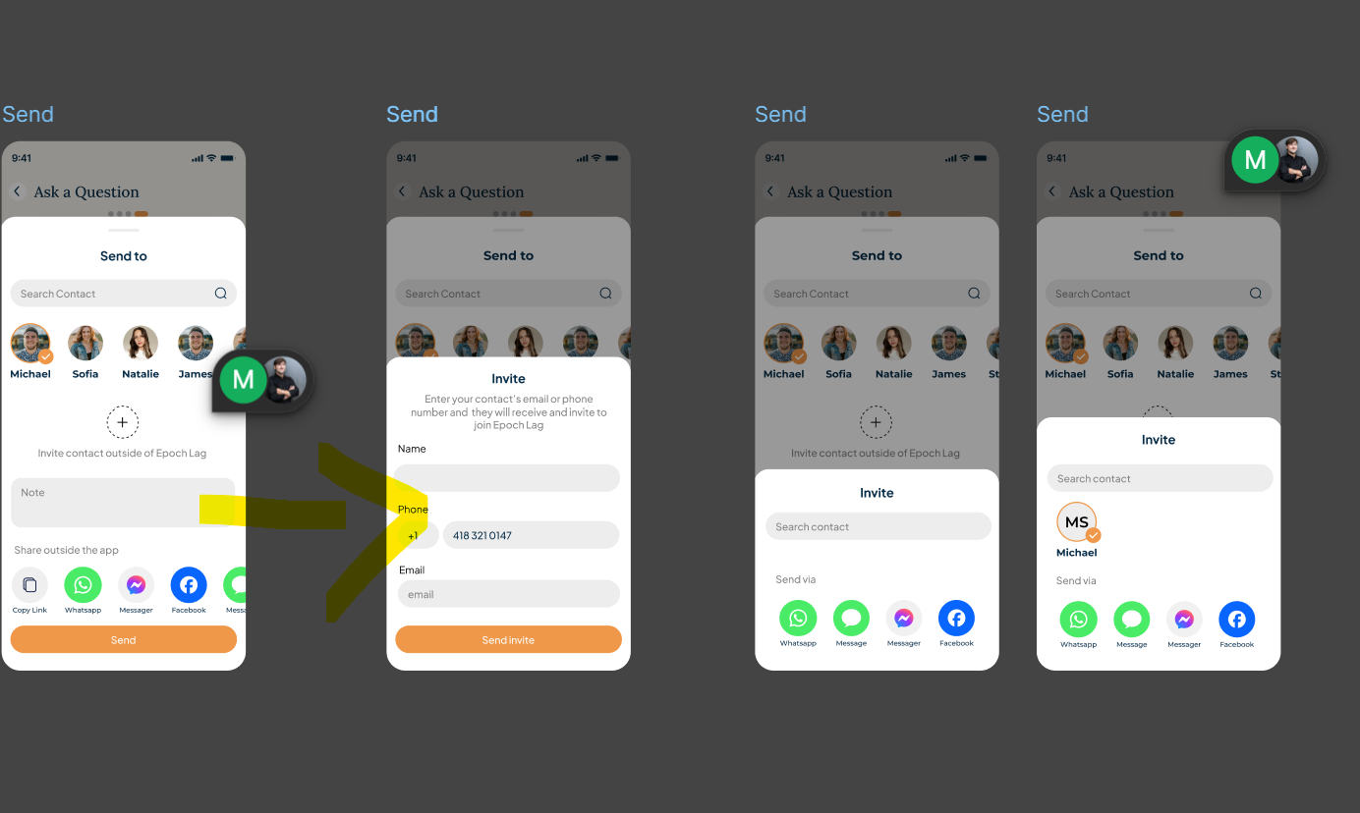
In the above flow, Yash clicks on + plus button:
Now he has two options: Either he writes Vivek and someone from his contacts matches and the name, phone number and email auto-fills or Yash writes Vivek and his phone number manually.
Once that is done -> He clicks on Send Invite and the third party popup comes next with preselected Vivek with an Avatar and when Yash clicks on any app icon and it comes with a share link.
In this link you need to add the profile info of the replying user using query param. You can add -> email, phone number and name and any one of them can be good enough for Yash to know that Vivek has replied with his story and Yash can view that story in his story thread with Vivek’s name in the author.
Note: For complexity purpose, we are only allowing the users to only add one user at a time right now.
Here’s the reply flow for this case:
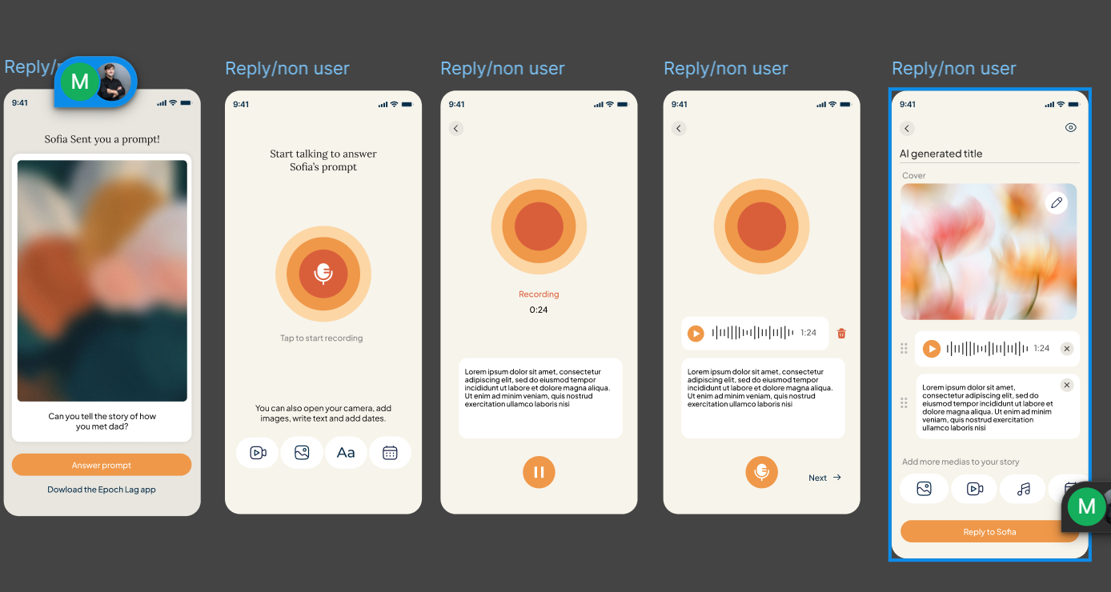

Note that this flow doesn’t have any login required. Once the reply is done -> you can take the user to public story page.

Edge Cases:
- User is already logged via webapp on their phone: In this case, we can just put the logged in user details like their name, phone, userid, email etc. to reply flow. I think we should just use a anon-reply user flow at the backend. Where we takes who is replying as parameters from the frontend itself.
- User already has the app installed (Mac will mostly test this and mostly have issues around this): We need to handle this case carefully. The link should take the user to the web page and Answer button should directly open the app itself with the reply flow.

